

Faculty of Engineering and Computer Science

Department of Computer science

First semester 2022/2023

Comp4388 – Machine Learning

Project 2 Report

Prepared by:

Salem Mufarreh 1190416

Laith Isbaitan 1190628

Prepared for:

Dr. Radi Jarar

# Table of Contents

Table of Contents 2

Table of figures 3

1. Introduction 4

2. EDA 4

2.1. Summery Statics 4

2.2. Missing Values Check 5

3. Detecting outliers 5

4. Removing outliers 9

5. Correlation Matrix 11

# Table of figures

Figure 1 Outliers Detected 6

Figure 2 MaxTemp outliers (1-4) 7

Figure 3 MaxTemp outliers (5-8) 8

Figure 4 MaxTemp outliers (9-12) 9

Figure 5 MaxTemp for Region (1-4) without outliers 10

Figure 6 Decision Tree plot 13

# Introduction

# EDA

## Summery Statics

Data columns (total 21 columns):  
 # Column Non-Null Count Dtype  
--- ------ -------------- -----  
 0 Date 36529 non-null datetime64[ns]  
 1 Location 36529 non-null object  
 2 MinTemp 36529 non-null float64  
 3 MaxTemp 36529 non-null float64  
 4 Rainfall 36529 non-null float64  
 5 WindGustDir 36529 non-null object  
 6 WindGustSpeed 36529 non-null float64  
 7 WindDir9am 36529 non-null object  
 8 WindDir3pm 36529 non-null object  
 9 WindSpeed9am 36529 non-null float64  
 10 WindSpeed3pm 36529 non-null float64  
 11 Humidity9am 36529 non-null float64  
 12 Humidity3pm 36529 non-null float64  
 13 Pressure9am 36529 non-null float64  
 14 Pressure3pm 36529 non-null float64  
 15 Cloud9am 36529 non-null float64  
 16 Cloud3pm 36529 non-null float64  
 17 Temp9am 36529 non-null float64  
 18 Temp3pm 36529 non-null float64  
 19 RainToday 36529 non-null object  
 20 RainTomorrow 36529 non-null object  
dtypes: datetime64[ns](1), float64(14), object(6)  
memory usage: 5.9+ MB

## Missing Values Check

Date 0  
Location 0  
MinTemp 500  
MaxTemp 369  
Rainfall 690  
WindGustDir 4936  
WindGustSpeed 4932  
WindDir9am 4477  
WindDir3pm 2103  
WindSpeed9am 831  
WindSpeed3pm 1475  
Humidity9am 667  
Humidity3pm 1333  
Pressure9am 6692  
Pressure3pm 6683  
Cloud9am 15817  
Cloud3pm 16139  
Temp9am 437  
Temp3pm 1105  
RainToday 690  
RainTomorrow 690  
dtype: int64

Two steps were made to replace the missing values:

1. Replacing the messing values in numerical columns, we used the median to replace any missing value.
2. Replacing the messing values in categorical columns we used the most used category in the column to replace it.

## Detecting outliers

To detect the outliers, we used Interquartile range (IQR) method: The IQR method calculates the range between the first and third quartiles of the data (Q1 and Q3), and any data point outside of 1.5 times the IQR is considered an outlier.

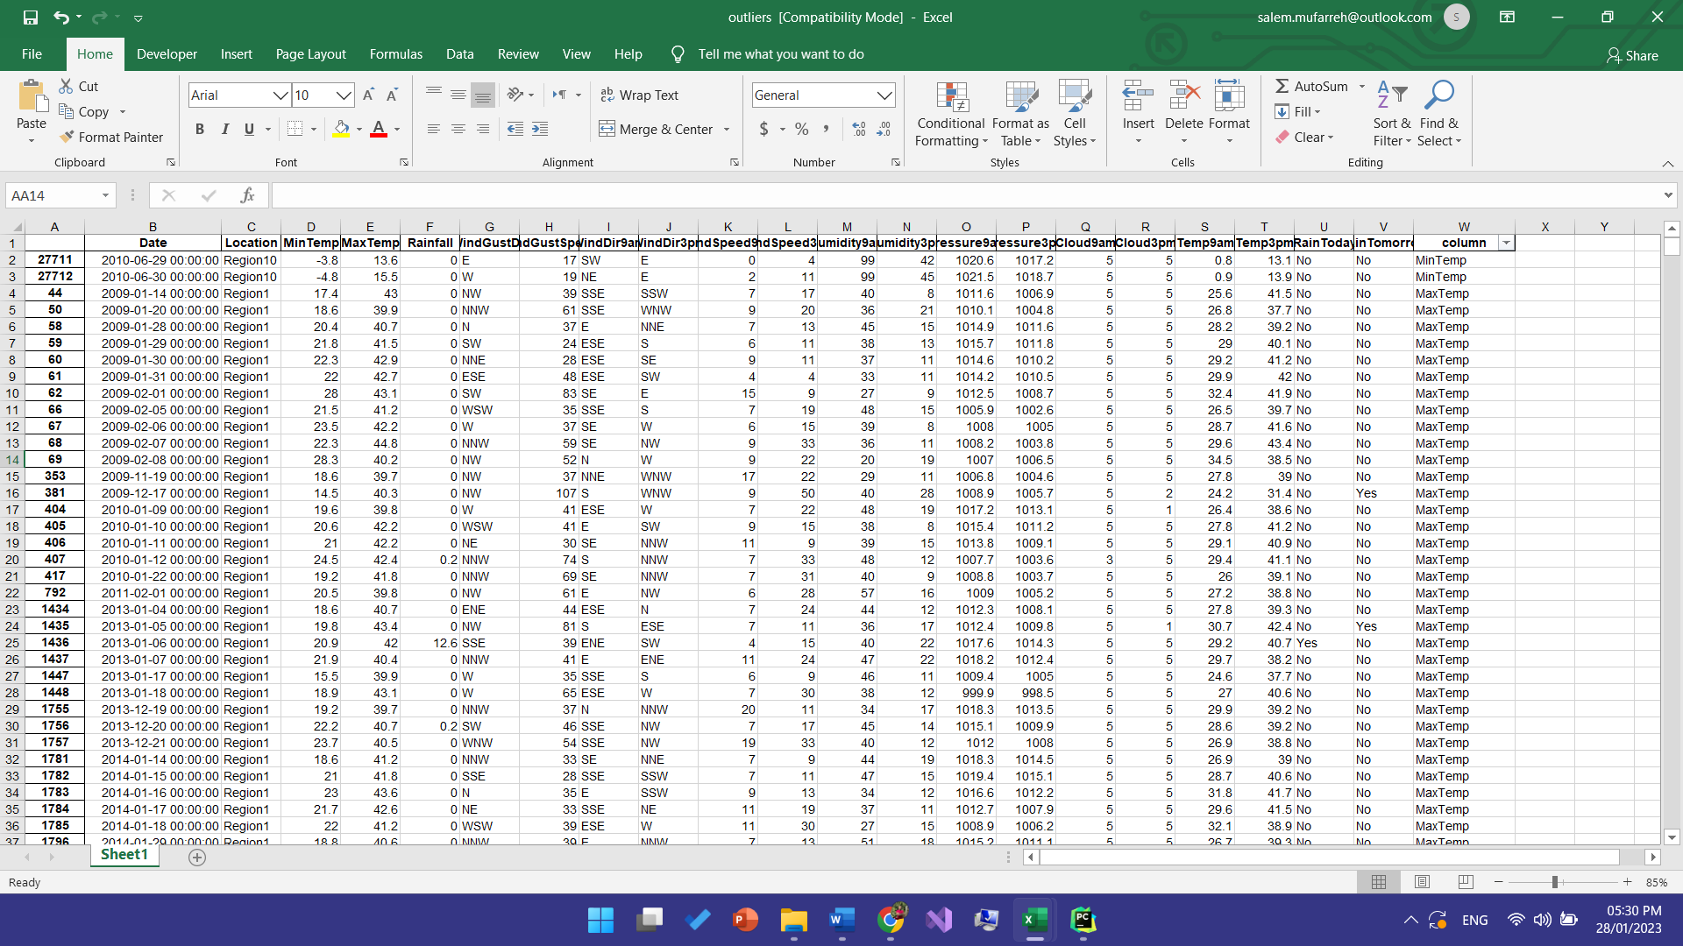

Figure 1 Outliers Detected

Looking at the outliers for region 10 we noticed that there are two outliers for minimum temperature which we can exclude from our data analysis.

For region1 we have 55 rows of outliers that say the temperature above 40 degrees are outliers, after studying the data we noticed that due to high temperature the humidity was low. Referring to the relation between humidity and temperature formula simply says they are inversely proportional. If temperature increases it will lead to a decrease in relative humidity, thus the air will become drier whereas when temperature decreases, the air will become wet means the relative humidity will increase.

We decided on eliminating the outliers that are higher than the average of these outliers. To keep as much data as possible and try to eliminate any possible outliers

Using the figures below we will notice each region and its Max Temperature outliers

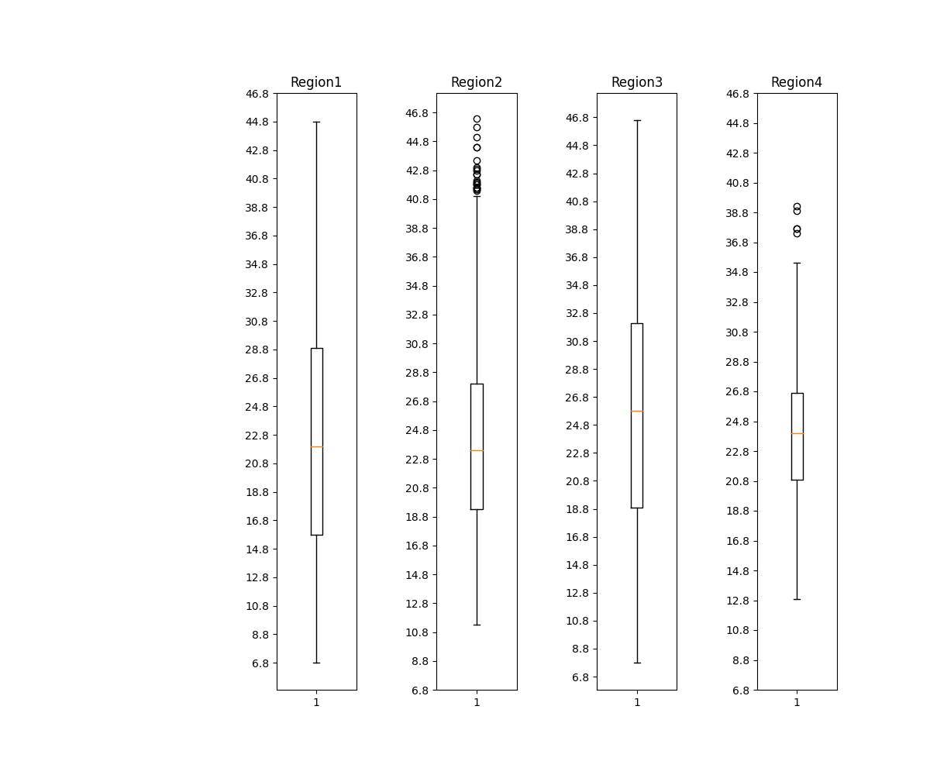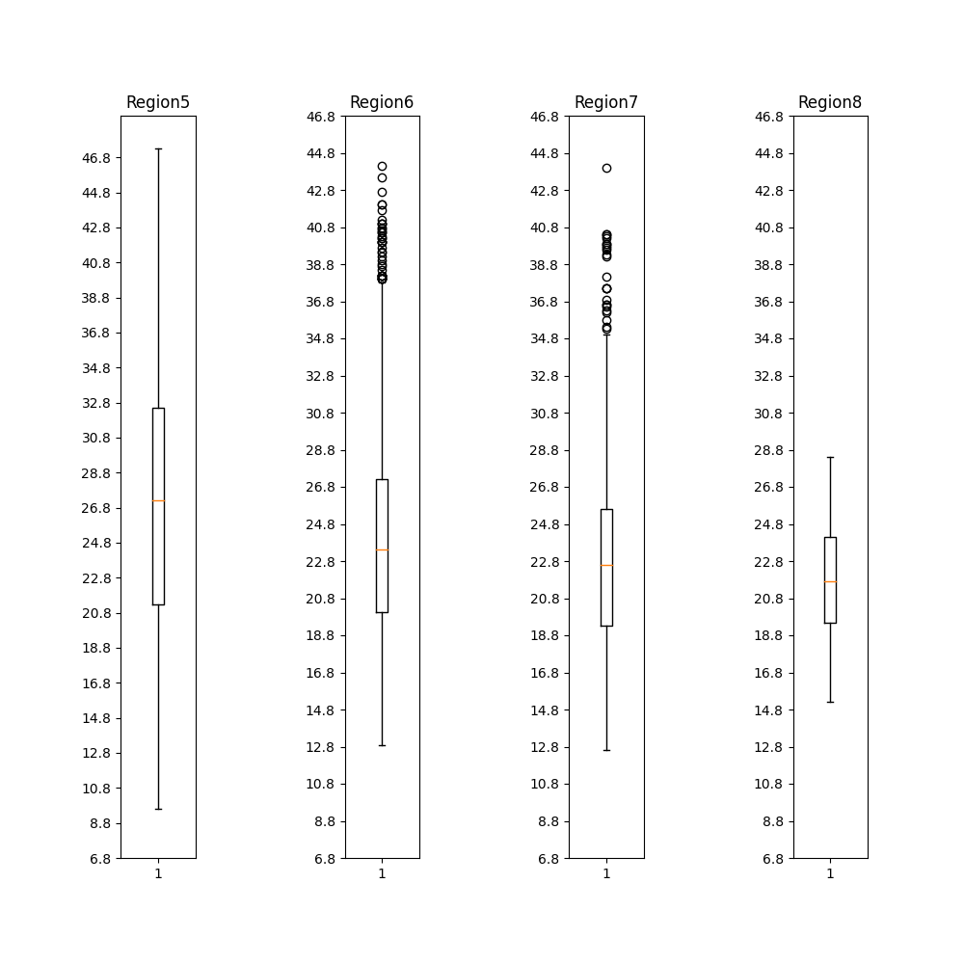

Figure 2 MaxTemp outliers (1-4)

Figure 3 MaxTemp outliers (5-8)

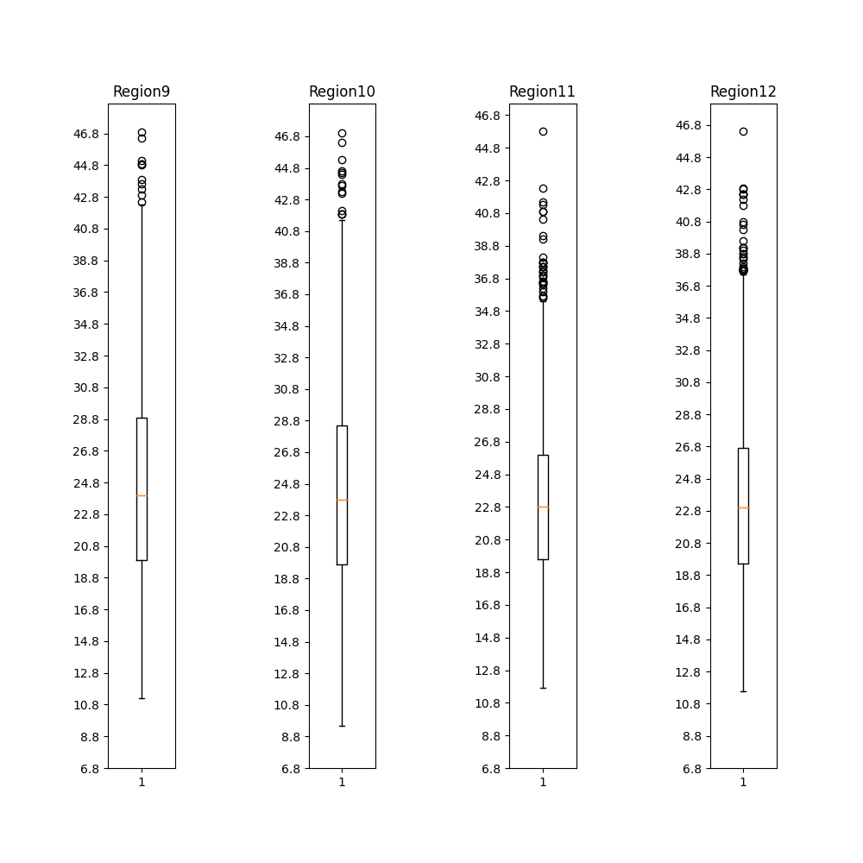

Figure 4 MaxTemp outliers (9-12)

## Removing outliers

Initially, we noticed that the presence of outliers in our data could potentially affect the results of our experiment. To better understand their impact, we first visualized the distribution of the data using box plots. After observation, it was clear that the outliers were largely due to high temperature spikes in various regions. These temperature fluctuations are not uncommon and can occur periodically in different regions.

As a first step to mitigate the impact of outliers, we decided to remove them from the dataset and ran our first set of tests, the results of which are shown in Table 1: Classifiers Results -- Removing Outliers. However, eliminating outliers also meant losing valuable information from the affected rows. To balance this, we replaced all outliers with the mean value for each respective column. This approach allowed us to retain meaningful information while still addressing the issue caused by outliers. The results of the second test are shown in Table 2: Classifiers Results -- Replacing Outliers.

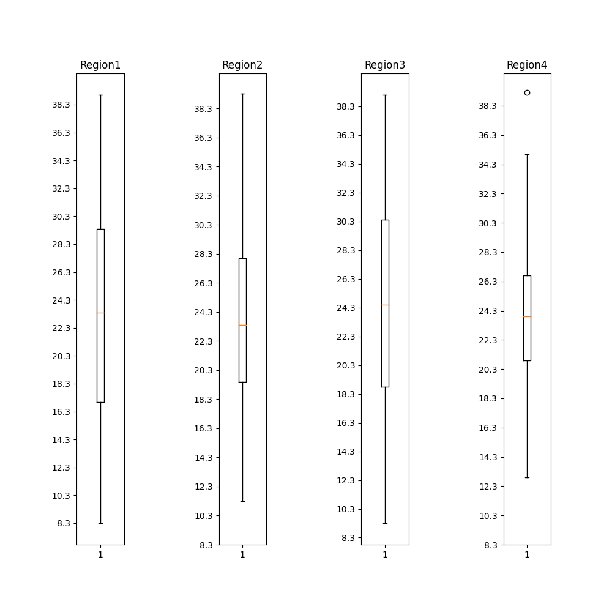

Figure 5 After Removing the outliers

## Correlation Matrix

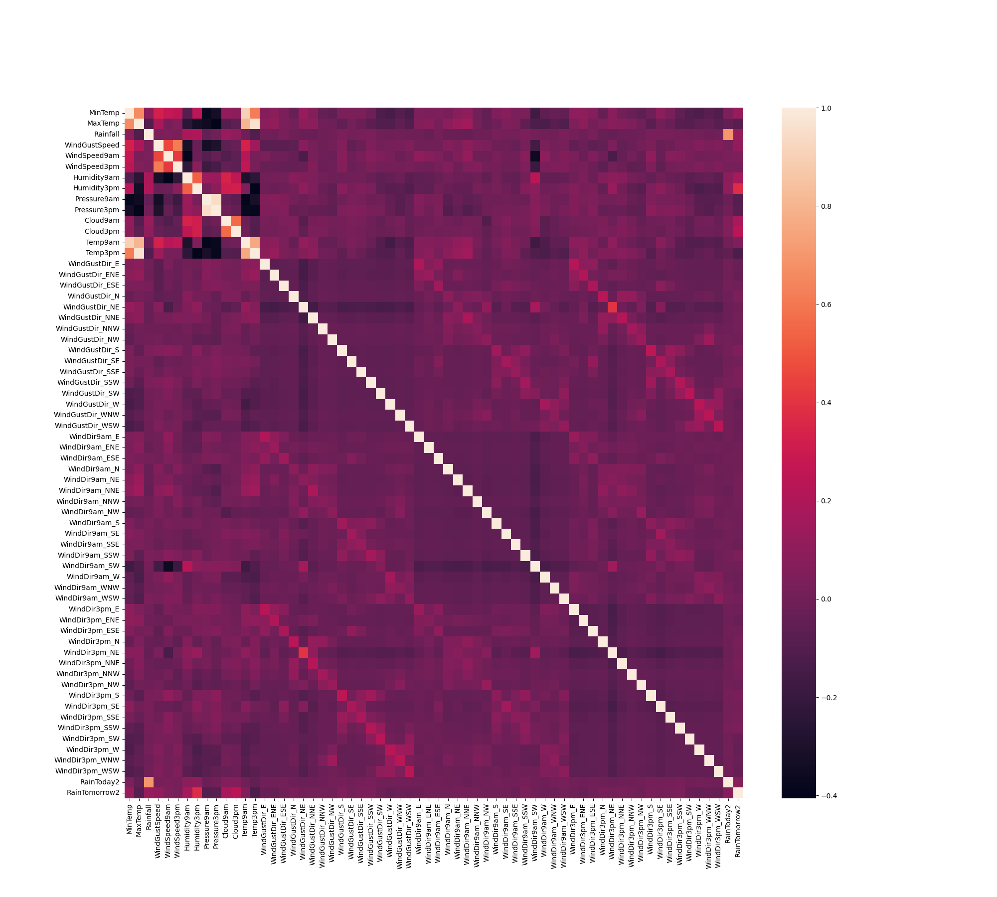

The correlation map indicates that the target column "Rain Tomorrow" has strong correlation with columns "humidity9am", "humidity3pm", "cloud9am", and "cloud3pm". On the other hand, the correlation between "Rain Tomorrow" and columns "MaxTemp", "pressure9am", "pressure3pm", "Temp3pm", and "windDir3pm_2" is weak.

# Algorithms

Based on the task of predicting the class target “Rain tomorrow” we choose to test the following classification algorithms:

* Naïve Bayes
* K nearest neighbor (KNN)
* Logistic Regression
* Decision Tree
* Support Vector Machine (SVM)

# Results

Removing the outliers

|  |  |  |  |  |  |  |  |
| --- | --- | --- | --- | --- | --- | --- | --- |
| **Classifier** | **Accuracy** | **Precision** | **Recall** | **TP** | **FP** | **FN** | **TN** |
| ***Naïve Bayes*** | 0.74151018 | 0.28778625 | 0.5108401 | 3335 | 933 | 361 | 377 |
| ***KNN*** | 0.87195365 | 0.77094972 | 0.18699186 | 4227 | 41 | 600 | 138 |
| ***Logistic Regression*** | 0.87355173 | 0.68041237 | 0.26829268 | 4175 | 93 | 540 | 198 |
| ***Decision Tree*** | 0.87155413 | 0.69230769 | 0.23170731 | 4192 | 76 | 567 | 171 |
| ***SVM*** | 0.87435077 | 0.6925795 | 0.26558265 | 4181 | 87 | 542 | 196 |

Table 1 Classifiers Results -- Removing outliers

Replace the outliers with median

|  |  |  |  |  |  |  |  |
| --- | --- | --- | --- | --- | --- | --- | --- |
| **Classifier** | **Accuracy** | **Precision** | **Recall** | **TP** | **FP** | **FN** | **TN** |
| ***Naïve Bayes*** | 0.72433616 | 0.40881590 | 0.59422111 | 4346 | 1368 | 646 | 946 |
| ***KNN*** | 0.840815767 | 0.768460575 | 0.385678392 | 5529 | 185 | 978 | 614 |
| ***Logistic Regression*** | 0.839857652 | 0.714867618 | 0.440954773 | 5434 | 280 | 890 | 702 |
| ***Decision Tree*** | 0.8362989323 | 0.7757660167 | 0.349874372 | 5553 | 161 | 1035 | 557 |
| ***SVM*** | 0.8402682727 | 0.7118644068 | 0.448492462 | 5425 | 289 | 878 | 714 |

Table 2 Classifiers Results -- Replacing outliers

## Decision Tree Result

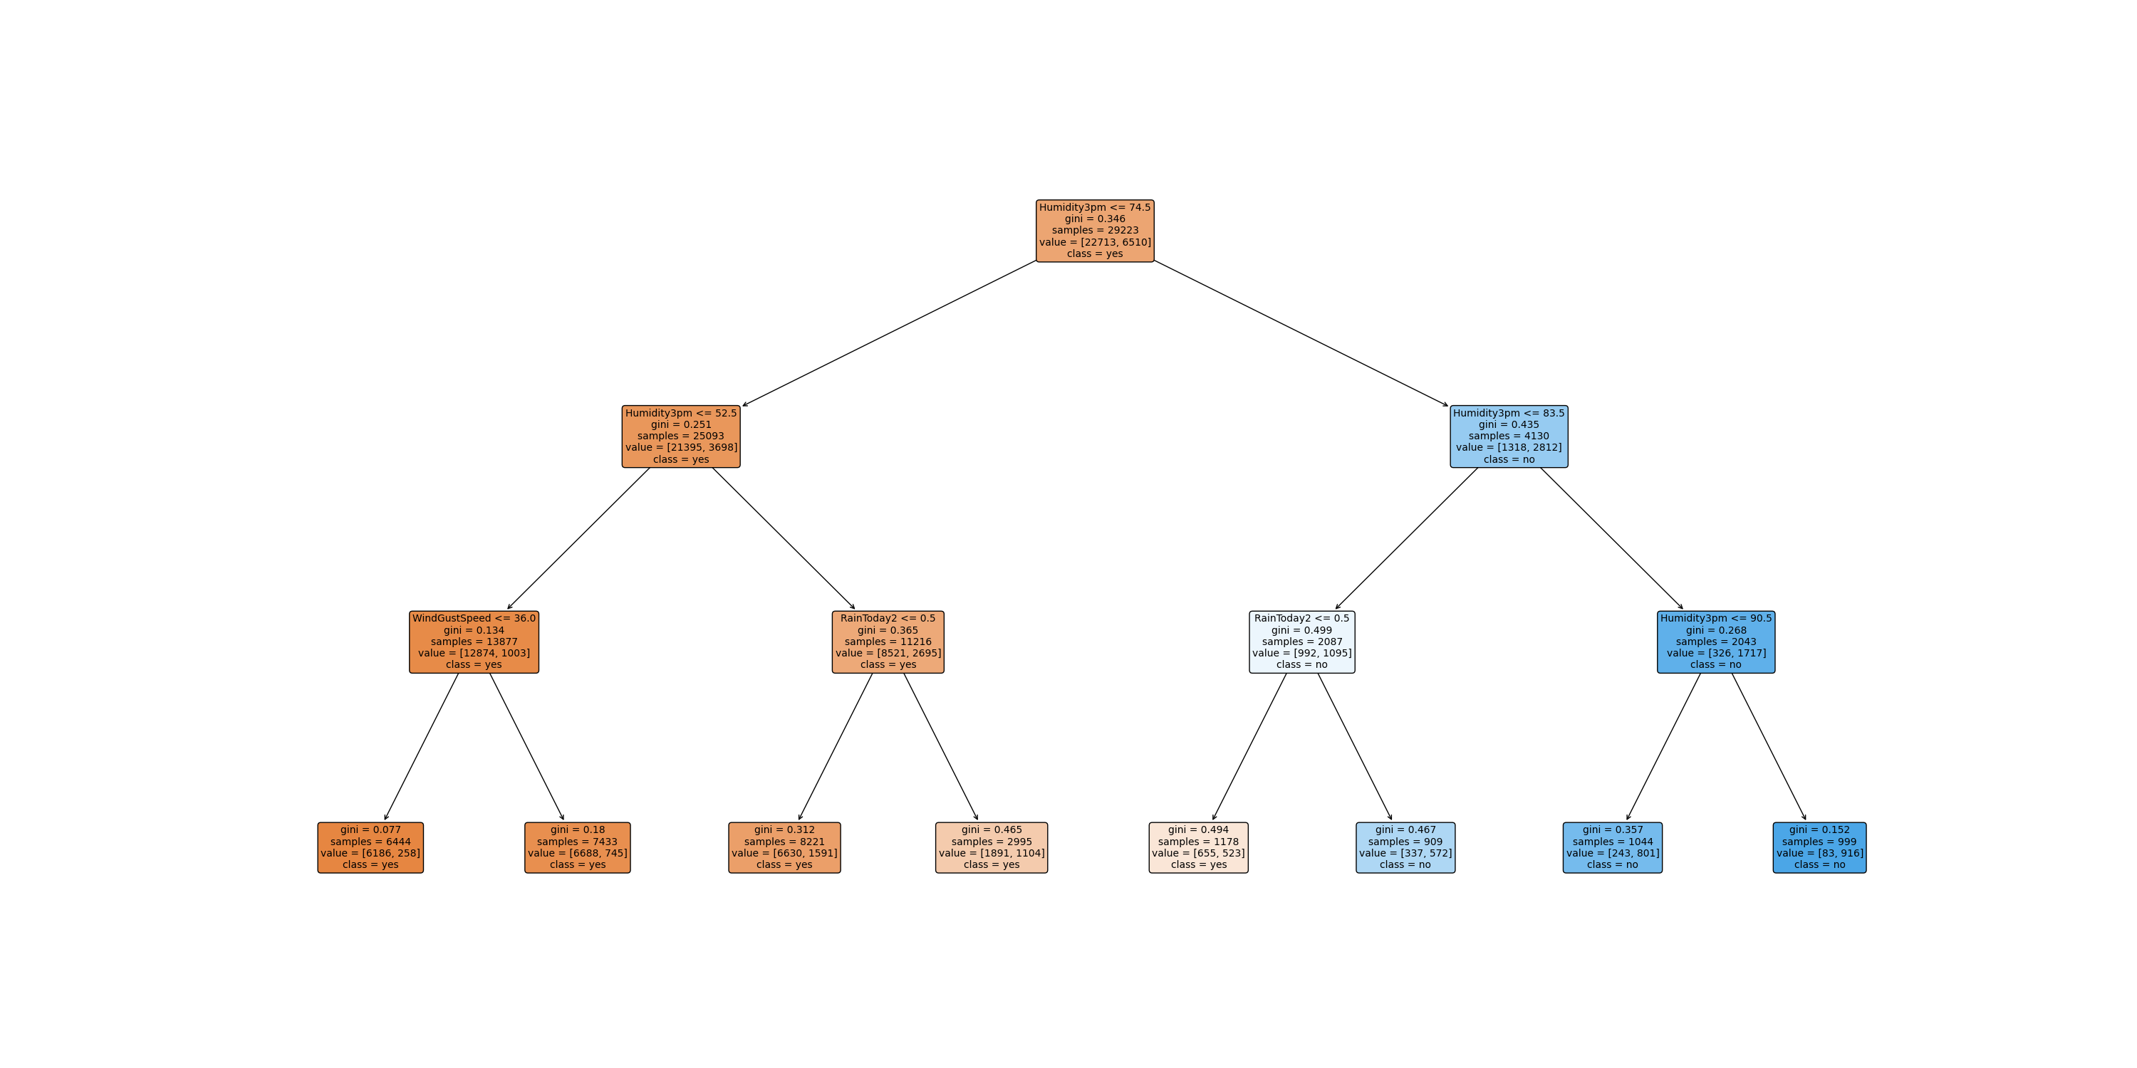

Figure 6 Decision Tree plot